Feb 9th Weekend

Bank-309

Total = 309+15=324

Minute 20 th- won 30.66(10.66)

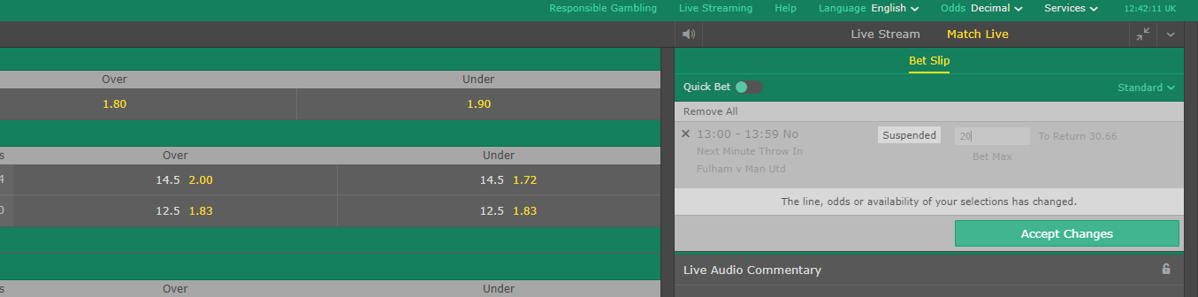

Calum chambers won 47.5(37.5)

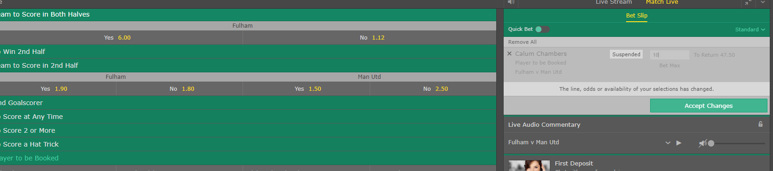

23rd minute lost 30

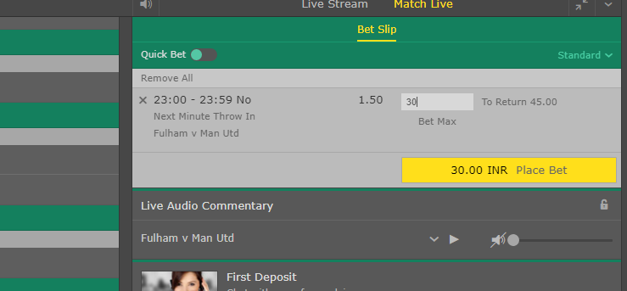

Lost 34th minute 20 euros

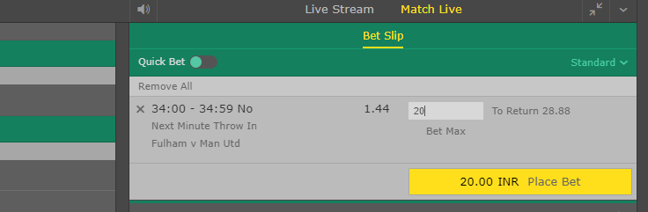

37th minu lost 10

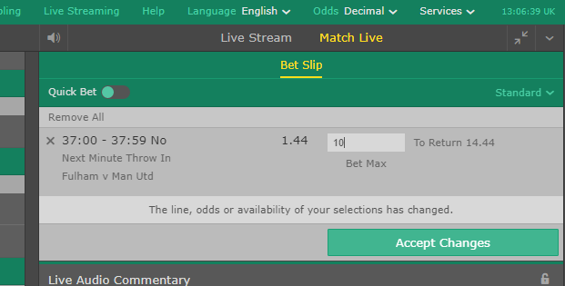

Won 21.6(6.6)

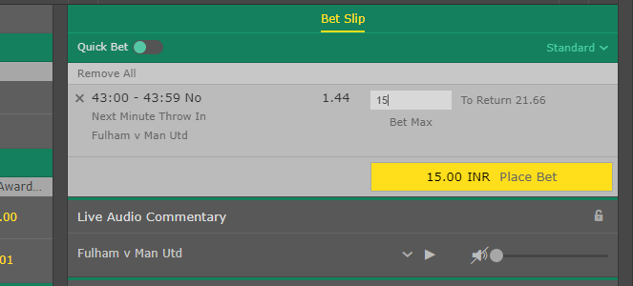

Ryan babel 2nd shot + and phil jones booking- 20 euro commited

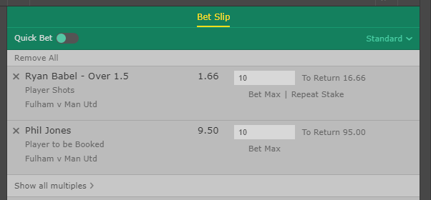

Lost 10-6.66=3.5 negative

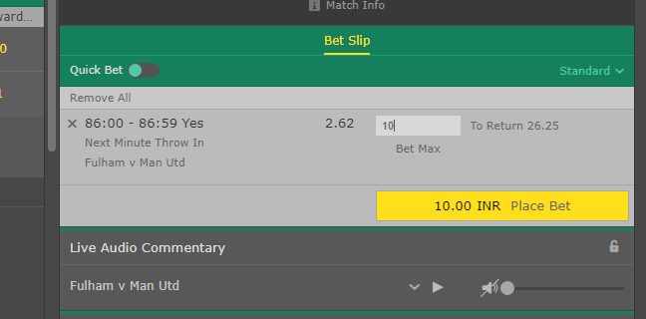

Won 75(25)

